Advanced Programming for Robotic
Quadcopter Development

Introduction
This project is designed for the student to participate in the multidisciplinary study of robotic technology. The project is focused on developing the engineering literacies of students, e.g., skill development, self-driven learning, and teamwork development. After the project, students will be able to:
- Apply problem-solving strategies to various technical problems that are increasing in complexity.
- Analyse different robotic programming concepts and apply them to a particular programming problem.
- Design, develop, test and document for the development of robotic applications.
- Develop applications to control sensor inputs and outputs connected to a microcontroller.
Objective
Essential
- Use the ESP32 Dev Board to develop a flight controller for the F450 quadcopter.
- Develop the 3D model for the holder of the developed ESP32-based flight controller to fit in an F450 quadcopter frame and have the 3D printed frame.
Optional
- Develop an F450 quadcopter frame and have the frame printed.
- Determine the appropriate component for the assembly of 3D printed F450 frame
- Assemble the quadcopter using the developed ESP32-Devboard-based flight controller and F450 3D printed frame.
- Complete the binding process for the Flysky remote controller and receivers and develop an operation manual for the binding process.
- Able to have the basic pilot skill of operating a quadcopter.

Self-driven learning
Understanding the motor configuration
- Numbering of the motors
- The direction of motor rotation
- Connection of motor to ESC clockwise vs anticlockwise
Understanding the connection of MPU6050 with the ESP32-Dev board
Understanding the system configuration of the typical quadcopter system.
Understanding the drone health and safety regulations.
3D modelling and 3D print development
- Develop F450 3D model and 3D print the developed F450 Frame
- Develop holder for ESP32-based flight controller with the MPU6050 Gyroscope

Components
- Quadcopter frame F450
- The flight controller ESP32-DevKit V1 (30 pins)
- RC Receiver Flysky FS-iA6B
- RC remote controller Flysky FS-i6
- Lipo Battery 3s Lipo Battery
- Gyro-scope MPU6050
- Propeller CW x 2, CCW x 2

ESP32-DevKit V1 Board (30 pins)
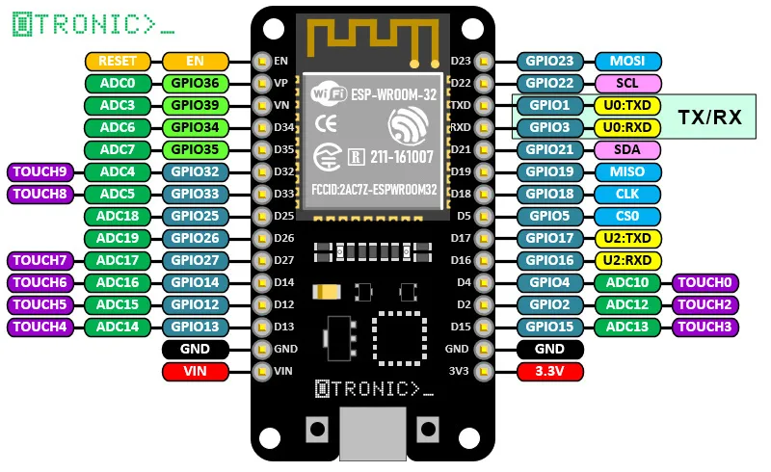
Reference: https://www.otronic.nl/fr/esp32-wroom-4mb-devkit-v1-avec-broches-den-tete-se.html

F450 Quadcopter Frame
The DJI F450 Quadcopter is a classic quadcopter frame standard for drone development. It could be the most popular drone frame standard for beginners in drone DIY development.
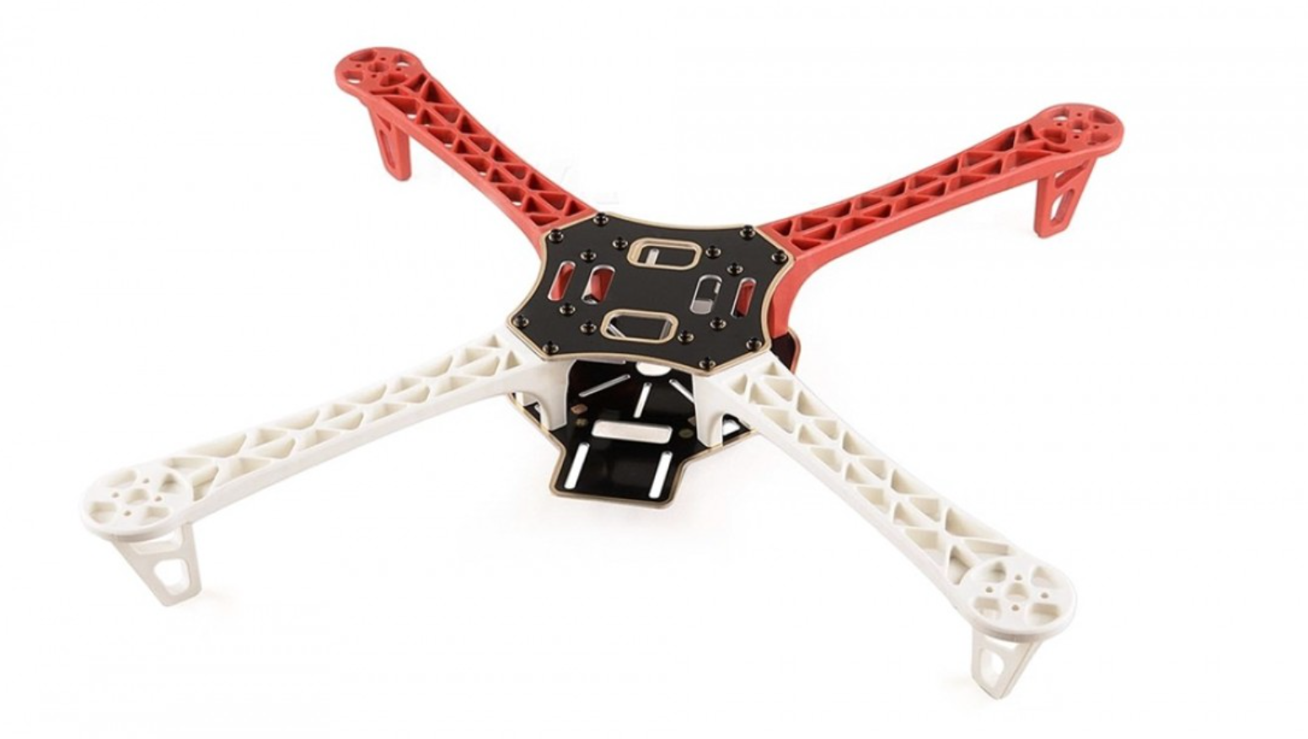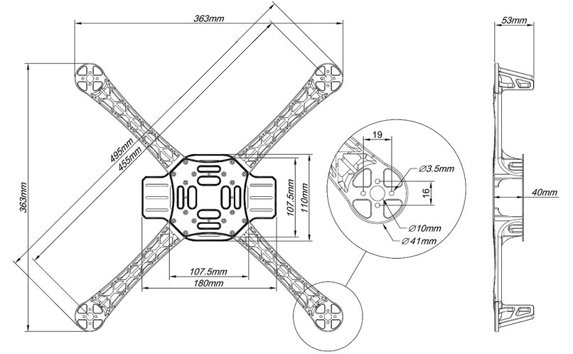
Reference: F450/Q450 Quadcopter frame Kit with integrated PCB (veerobot.com)
Reference: F450 dimensions · Large Quadcopter Build (george-hawkins.github.io)

Inertial Measurement Unit (IMU) MPU6050
The MPU-60X0 is the world’s first integrated 6-axis MotionTracking device that combines a 3-axis gyroscope, 3-axis accelerometer, and a Digital Motion Processor™ (DMP) all in a small 4x4x0.9mm package. With its dedicated I2C sensor bus, it directly accepts inputs from an external 3-axis compass to provide a complete 9-axis MotionFusion™ output. The MPU-60X0 MotionTracking device, with its 6-axis integration, onboard MotionFusion™, and run-time calibration firmware, enables manufacturers to eliminate the costly and complex selection, qualification, and system level integration of discrete devices, guaranteeing optimal motion performance for consumers. The MPU-60X0 is also designed to interface with multiple non-inertial digital sensors, such as pressure sensors, on its auxiliary I2C port. The MPU-60X0 is footprint-compatible with the MPU-30X0 family.
Reference: MPU-6000 and MPU-6050 Product Specification Revision 3.4

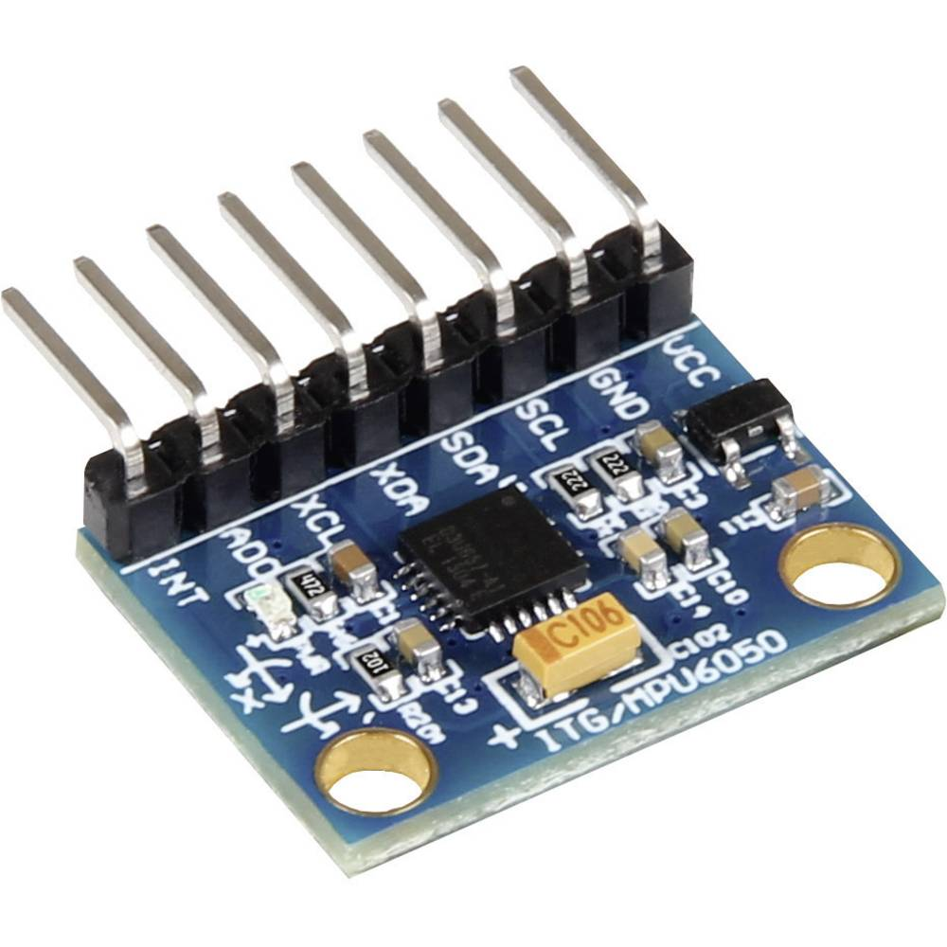
Figure MPU6050

Flight Controller Program Configuration
For reference information, see the project in Git Hub, ESP32-Flight-controller. Reference: https://github.com/pratikPhadte/ESP32-Flight-controller
The flight controller program can be found in GitHub, in the above link, Anglemode_flightcontroller_ver3.ino
To configure the program, the essential library, ESP32Servo.h, needs to be installed. Open the library manager, search the keyword ‘ESP32Servo.h’, the search result shows a library ESP32Servo by K. Harrington and J. K. Bennett. The library allows ESP32 boards to control servo.
Connection of FLYSKY FS-iA6B RC Receiver with ESP32 DevKit V1
The connection of FS-iA6B with the ESP32-DevKit-V1
FS-iA6B RC receiver | ESP320-DevKit-V1
CH1 | D34
CH2 | D35
CH3 | D32
CH4 | D33
CH5 | D25
CH6 (top pin) | D26
CH6 (middle pin) | VIN
CH6 (bottom pin) | GND

Connection of the IMU Sensor (MPU6050) via I2C connection with ESP32 DevKit V1
- The MPU6050 should place at the very centre of the quadcopter.
- Keep the MPU6050 solder line facing to the rear of the quadcopter.

Sensor Gyroscope (MPU6050) | ESP32 DevKit V1 board (30-pins) | Actual Pin Connection
SCL | I2C_CLK | Pin D22_SCL (GPIO22)
SDA | I2D_SDA | Pin D21_SDA (GPIO 21)
INT | IMU_EXIT | N/A
VCC | 3V3 | 3.3 V
GND | GND | GND

Connection of the Electronic Speed Controller (ESC) with ESP32 DevKit V1
ESC | ESP32 DevKit V1 board (30-pins) | Actual Pin Connection
Motor 1 (white cable) | GPIO 13 | D13
Motor 2 (white cable) | GPIO 12 | D12
Motor 3 (white cable) | GPIO 14 | D14
Motor 4 (white cable) | GPIO 27 | D27
GND (black cable) | GND | GND

To check either the ESC and motor are functional:
Prior to checking, the remote controller must bind with the receiver.
Connect the ESC’s signal connector to channel 3 of the FS-iA6B, which is the throttle signal.
The FS-iA6B needs to power on and connect the battery to the ESC.
If the ESC does not receive any or correct signal from the receiver (this may be because the remote controller is not turned ON), it will give constant beeping of about 1-second duration.
If the ESC receive the the correct signal from the receiver, a self-calibration sound will be given:

Definition of Motor Location and Rotation Direction
For the DJI product standard, i.e. the motor and propeller, the CW is given in Black nuts, and the CCW is given in Silver nuts.
Front
Motor ID | Location | Rotation Direction
1 | Front Right | CCW
2 | Rear Right | CW
3 | Rear Left | CCW
4 | Front Left | CW
Back

Motor rotation can switch between CW and CCW by switching any two wires' connections.

FS-i6 remote controller and FS-iA6B receiver Binding
The binding process is straightforward:
- Insert the bind key (the wire clip usually comes with the receiver’s package) into the FS-iA6B receiver’s B/VCC channel.
- Apply 5V and GND to any channel’s middle and bottom pins. (The 5V and GND can be obtained from the power supply unit via two male-to-female Dupo wires.)
- After connecting the 5V and GND to the channel, the FS-iA6B receiver's LED will flash.
- Keep pressing the bind key of the remote controller, located at the bottom left corner of the remote controller and turn on the remote controller's power.
- The FS-iA6B receiver's LED will stop flashing and turn to constant ON, indicating that the binding is successful.
(If the process is different from the above description, it may be due to the remote controller or receiver being faulty, although it is improbable will happen.)

FS-i6 remote controller configuration

The program files for this quadcopter development project
Reference: GitHub: https://github.com/pratikPhadte/ESP32-Flight-controller-
- Angemode_flightcontroller_ver3
This is the complete code for the ESP32 flight controller, you may have to upload additional libraries in your Arduino ide. Before uploading the code in the ESP32, keep the quadcopter on a spirit-level surface, when the code is uploaded in the ESP32, Make sure to give an initial 10s calibration time for the quadcopter to calibrate Gyro, now after 2 LED blinks on the pin15 the quadcopter is ready for flight.

- receiver_pwm_esp32 - This code is independently to test the receiver & transmitter signals on serial monitor. connect the receiver to the esp32 board as mentioned in the schematic.
- measure_angles_mpu - IMU angle checker, connect the imu to the esp32 via the i2c protocal as mentioned in the schematic.
- Motors calibration - The motor's ESCs have to be calibrated before the flight, such that they start simultaneously, run this code first and calibrate your ESC as per the proper procedure.
- Voltage measurement esp32 - this code will measure the voltage level of the Lipo 11v battery, you may have to adjust the code values of the resistors as per your -actual resistor values used in the circuit.

Appendix
ESP32 Flight Controller Program
#include <Wire.h>
#include <ESP32Servo.h> // Change to the standard Servo library for ESP32

volatile float RatePitch, RateRoll, RateYaw;
volatile float RateCalibrationPitch, RateCalibrationRoll, RateCalibrationYaw;
int RateCalibrationNumber;

Servo mot1;
Servo mot2;
Servo mot3;
Servo mot4;
const int mot1_pin = 13;
const int mot2_pin = 12;
const int mot3_pin = 14;
const int mot4_pin = 27;

volatile uint32_t current_time;
volatile uint32_t last_channel_1 = 0;
volatile uint32_t last_channel_2 = 0;
volatile uint32_t last_channel_3 = 0;
volatile uint32_t last_channel_4 = 0;
volatile uint32_t last_channel_5 = 0;
volatile uint32_t last_channel_6 = 0;
volatile uint32_t timer_1;
volatile uint32_t timer_2;
volatile uint32_t timer_3;
volatile uint32_t timer_4;
volatile uint32_t timer_5;
volatile uint32_t timer_6;
volatile int ReceiverValue[6]; // Increase the array size to 6 for Channel 1 to Channel 6
const int channel_1_pin = 34;
const int channel_2_pin = 35;
const int channel_3_pin = 32;
const int channel_4_pin = 33;
const int channel_5_pin = 25;
const int channel_6_pin = 26;

// float voltage;

float DesiredRateRoll, DesiredRatePitch, DesiredRateYaw;
float ErrorRateRoll, ErrorRatePitch, ErrorRateYaw;
float InputRoll, InputThrottle, InputPitch, InputYaw;
float PrevErrorRateRoll, PrevErrorRatePitch, PrevErrorRateYaw;
float PrevItermRateRoll, PrevItermRatePitch, PrevItermRateYaw;
float PIDReturn[] = {0, 0, 0};

// float AccX, AccY, AccZ;
// float AngleRoll, AnglePitch;
// float KalmanAngleRoll=0, KalmanUncertaintyAngleRoll=2*2;
// float KalmanAnglePitch=0, KalmanUncertaintyAnglePitch=2*2;
// float Kalman1DOutput[]={0,0};

float PRateRoll = 0.75; //For outdoor flights, keep this gain to 0.75 and for indoor flights keep the gain to be 0.6
float IRateRoll = 0.012;
float DRateRoll = 0.0085;

float PRatePitch = PRateRoll;
float IRatePitch = IRateRoll;
float DRatePitch = DRateRoll;

float PRateYaw = 4.2;
float IRateYaw = 2.8;
float DRateYaw = 0;

uint32_t LoopTimer;
float t=0.006; //time cycle

//Kalman filters for angle mode
volatile float AccX, AccY, AccZ;
volatile float AngleRoll, AnglePitch;
volatile float KalmanAngleRoll=0, KalmanUncertaintyAngleRoll=2*2;
volatile float KalmanAnglePitch=0, KalmanUncertaintyAnglePitch=2*2;
volatile float Kalman1DOutput[]={0,0};
volatile float DesiredAngleRoll, DesiredAnglePitch;
volatile float ErrorAngleRoll, ErrorAnglePitch;
volatile float PrevErrorAngleRoll, PrevErrorAnglePitch;
volatile float PrevItermAngleRoll, PrevItermAnglePitch;
float PAngleRoll=2; float PAnglePitch=PAngleRoll;
float IAngleRoll=0; float IAnglePitch=IAngleRoll;
float DAngleRoll=0; float DAnglePitch=DAngleRoll;
void kalman_1d(float KalmanState, float KalmanUncertainty, float KalmanInput, float KalmanMeasurement) {
KalmanState=KalmanState + (t*KalmanInput);
KalmanUncertainty=KalmanUncertainty + (t*t*4*4); //here 4 is the vairnece of IMU i.e 4 deg/s
float KalmanGain=KalmanUncertainty * 1/(1*KalmanUncertainty + 3 * 3); //std deviation of error is 3 deg
KalmanState=KalmanState+KalmanGain * (KalmanMeasurement-KalmanState);
KalmanUncertainty=(1-KalmanGain) * KalmanUncertainty;
Kalman1DOutput[0]=KalmanState;
Kalman1DOutput[1]=KalmanUncertainty;
}

volatile float MotorInput1, MotorInput2, MotorInput3, MotorInput4;

void channelInterruptHandler()
{
current_time = micros();
// Channel 1
if (digitalRead(channel_1_pin))
{
if (last_channel_1 == 0)
{
last_channel_1 = 1;
timer_1 = current_time;
}
}
else if (last_channel_1 == 1)
{
last_channel_1 = 0;
ReceiverValue[0] = current_time - timer_1;
}

// Channel 2
if (digitalRead(channel_2_pin))
{
if (last_channel_2 == 0)
{
last_channel_2 = 1;
timer_2 = current_time;
}
}
else if (last_channel_2 == 1)
{
last_channel_2 = 0;
ReceiverValue[1] = current_time - timer_2;
}

// Channel 3
if (digitalRead(channel_3_pin))
{
if (last_channel_3 == 0)
{
last_channel_3 = 1;
timer_3 = current_time;
}
}
else if (last_channel_3 == 1)
{
last_channel_3 = 0;
ReceiverValue[2] = current_time - timer_3;
}

// Channel 4
if (digitalRead(channel_4_pin))
{
if (last_channel_4 == 0)
{
last_channel_4 = 1;
timer_4 = current_time;
}
}
else if (last_channel_4 == 1)
{
last_channel_4 = 0;
ReceiverValue[3] = current_time - timer_4;
}

// Channel 5
if (digitalRead(channel_5_pin))
{
if (last_channel_5 == 0)
{
last_channel_5 = 1;
timer_5 = current_time;
}
}
else if (last_channel_5 == 1)
{
last_channel_5 = 0;
ReceiverValue[4] = current_time - timer_5;
}

// Channel 6
if (digitalRead(channel_6_pin))
{
if (last_channel_6 == 0)
{
last_channel_6 = 1;
timer_6 = current_time;
}
}
else if (last_channel_6 == 1)
{
last_channel_6 = 0;
ReceiverValue[5] = current_time - timer_6;
}
}

void neutralPositionAdjustment()
{
int min = 1490;
int max = 1510;
if (ReceiverValue[0] < max && ReceiverValue[0] > min)
{
ReceiverValue[0]= 1500;
}
if (ReceiverValue[1] < max && ReceiverValue[1] > min)
{
ReceiverValue[1]= 1500;
}
if (ReceiverValue[3] < max && ReceiverValue[3] > min)
{
ReceiverValue[3]= 1500;
}
if(ReceiverValue[0]==ReceiverValue[1] && ReceiverValue[1]==ReceiverValue[3] && ReceiverValue[3]==ReceiverValue[0] )
{
ReceiverValue[0]= 1500;
ReceiverValue[1]= 1500;
ReceiverValue[3]= 1500;
}

}
void gyro_signals(void)
{
Wire.beginTransmission(0x68);
Wire.write(0x1A);
Wire.write(0x05);
Wire.endTransmission();
Wire.beginTransmission(0x68);
Wire.write(0x1C);
Wire.write(0x10);
Wire.endTransmission();
Wire.beginTransmission(0x68);
Wire.write(0x3B);
Wire.endTransmission();
Wire.requestFrom(0x68,6);
int16_t AccXLSB = Wire.read() << 8 | Wire.read();
int16_t AccYLSB = Wire.read() << 8 | Wire.read();
int16_t AccZLSB = Wire.read() << 8 | Wire.read();
Wire.beginTransmission(0x68);
Wire.write(0x1B);
Wire.write(0x8);
Wire.endTransmission();
Wire.beginTransmission(0x68);
Wire.write(0x43);
Wire.endTransmission();
Wire.requestFrom(0x68,6);
int16_t GyroX=Wire.read()<<8 | Wire.read();
int16_t GyroY=Wire.read()<<8 | Wire.read();
int16_t GyroZ=Wire.read()<<8 | Wire.read();
RateRoll=(float)GyroX/65.5;
RatePitch=(float)GyroY/65.5;
RateYaw=(float)GyroZ/65.5;
AccX=(float)AccXLSB/4096;
AccY=(float)AccYLSB/4096;
AccZ=(float)AccZLSB/4096;
AccZ=AccZ-0.26; // calibration offset
AngleRoll=atan(AccY/sqrt(AccX*AccX+AccZ*AccZ))*1/(3.142/180);
AnglePitch=-atan(AccX/sqrt(AccY*AccY+AccZ*AccZ))*1/(3.142/180);
}

void pid_equation(float Error, float P, float I, float D, float PrevError, float PrevIterm)
{
float Pterm = P * Error;
float Iterm = PrevIterm +( I * (Error + PrevError) * (t/2));
if (Iterm > 400)
{
Iterm = 400;
}
else if (Iterm < -400)
{
Iterm = -400;
}
float Dterm = D *( (Error - PrevError)/t);
float PIDOutput = Pterm + Iterm + Dterm;
if (PIDOutput > 400)
{
PIDOutput = 400;
}
else if (PIDOutput < -400)
{
PIDOutput = -400;
}
PIDReturn[0] = PIDOutput;
PIDReturn[1] = Error;
PIDReturn[2] = Iterm;
}

void reset_pid(void)
{
PrevErrorRateRoll=0; PrevErrorRatePitch=0; PrevErrorRateYaw=0;
PrevItermRateRoll=0; PrevItermRatePitch=0; PrevItermRateYaw=0;
PrevErrorAngleRoll=0; PrevErrorAnglePitch=0;
PrevItermAngleRoll=0; PrevItermAnglePitch=0;
}

void setup(void) {

Serial.begin(115200);

int led_time=100;
pinMode(15, OUTPUT);
digitalWrite(15, LOW);
delay(led_time);
digitalWrite(15, HIGH);
delay(led_time);
digitalWrite(15, LOW);
delay(led_time);
digitalWrite(15, HIGH);
delay(led_time);
digitalWrite(15, LOW);
delay(led_time);
digitalWrite(15, HIGH);
delay(led_time);
digitalWrite(15, LOW);
delay(led_time);
digitalWrite(15, HIGH);
delay(led_time);
digitalWrite(15, LOW);
delay(led_time);

pinMode(channel_1_pin, INPUT_PULLUP);
pinMode(channel_2_pin, INPUT_PULLUP);
pinMode(channel_3_pin, INPUT_PULLUP);
pinMode(channel_4_pin, INPUT_PULLUP);
pinMode(channel_5_pin, INPUT_PULLUP);
pinMode(channel_6_pin, INPUT_PULLUP);

attachInterrupt(digitalPinToInterrupt(channel_1_pin), channelInterruptHandler, CHANGE);
attachInterrupt(digitalPinToInterrupt(channel_2_pin), channelInterruptHandler, CHANGE);
attachInterrupt(digitalPinToInterrupt(channel_3_pin), channelInterruptHandler, CHANGE);
attachInterrupt(digitalPinToInterrupt(channel_4_pin), channelInterruptHandler, CHANGE);
attachInterrupt(digitalPinToInterrupt(channel_5_pin), channelInterruptHandler, CHANGE);
attachInterrupt(digitalPinToInterrupt(channel_6_pin), channelInterruptHandler, CHANGE);

Wire.setClock(400000);
Wire.begin();
delay(250);
Wire.beginTransmission(0x68);
Wire.write(0x6B);
Wire.write(0x00);
Wire.endTransmission();

mot1.attach(mot1_pin,1000,2000);
mot2.attach(mot2_pin,1000,2000);
mot3.attach(mot3_pin,1000,2000);
mot4.attach(mot4_pin,1000,2000);
//to stop esc from beeping
mot1.write(0);
mot2.write(0);
mot3.write(0);
mot4.write(0);
digitalWrite(15, LOW);
digitalWrite(15, HIGH);
delay(2000);
digitalWrite(15, LOW);
delay(2000);

for (RateCalibrationNumber = 0; RateCalibrationNumber < 4000; RateCalibrationNumber++)
{
gyro_signals();
RateCalibrationRoll += RateRoll;
RateCalibrationPitch += RatePitch;
RateCalibrationYaw += RateYaw;
delay(1);
}
RateCalibrationRoll /= 4000;
RateCalibrationPitch /= 4000;
RateCalibrationYaw /= 4000;
//Gyro Calibrated Values
// Serial.print("Gyro Calib: ");
// Serial.print(RateCalibrationRoll);
// Serial.print(" ");
// Serial.print(RateCalibrationPitch);
// Serial.print(" ");
// Serial.print(RateCalibrationYaw);
// Serial.print(" -- ");

digitalWrite(15, HIGH);
delay(1000);
digitalWrite(15, LOW);
delay(1000);
digitalWrite(15, HIGH);
delay(1000);
digitalWrite(15, LOW);
delay(1000);

LoopTimer = micros();

}

void loop(void) {

//enter your loop code here
gyro_signals();
RateRoll -= RateCalibrationRoll;
RatePitch -= RateCalibrationPitch;
RateYaw -= RateCalibrationYaw;

kalman_1d(KalmanAngleRoll, KalmanUncertaintyAngleRoll, RateRoll, AngleRoll);
KalmanAngleRoll=Kalman1DOutput[0]; KalmanUncertaintyAngleRoll=Kalman1DOutput[1];
kalman_1d(KalmanAnglePitch, KalmanUncertaintyAnglePitch, RatePitch, AnglePitch);
KalmanAnglePitch=Kalman1DOutput[0]; KalmanUncertaintyAnglePitch=Kalman1DOutput[1];

channelInterruptHandler();
neutralPositionAdjustment();

DesiredAngleRoll=0.1*(ReceiverValue[0]-1500);
DesiredAnglePitch=0.1*(ReceiverValue[1]-1500);
InputThrottle=ReceiverValue[2];
DesiredRateYaw=0.15*(ReceiverValue[3]-1500);

ErrorAngleRoll=DesiredAngleRoll-KalmanAngleRoll;
ErrorAnglePitch=DesiredAnglePitch-KalmanAnglePitch;

pid_equation(ErrorAngleRoll, PAngleRoll, IAngleRoll, DAngleRoll, PrevErrorAngleRoll, PrevItermAngleRoll);
DesiredRateRoll=PIDReturn[0];
PrevErrorAngleRoll=PIDReturn[1];
PrevItermAngleRoll=PIDReturn[2];

pid_equation(ErrorAnglePitch, PAnglePitch, IAnglePitch, DAnglePitch, PrevErrorAnglePitch, PrevItermAnglePitch);
DesiredRatePitch=PIDReturn[0];
PrevErrorAnglePitch=PIDReturn[1];
PrevItermAnglePitch=PIDReturn[2];

ErrorRateRoll=DesiredRateRoll-RateRoll;
ErrorRatePitch=DesiredRatePitch-RatePitch;
ErrorRateYaw=DesiredRateYaw-RateYaw;

pid_equation(ErrorRateRoll, PRateRoll, IRateRoll, DRateRoll, PrevErrorRateRoll, PrevItermRateRoll);
InputRoll=PIDReturn[0];
PrevErrorRateRoll=PIDReturn[1];
PrevItermRateRoll=PIDReturn[2];

pid_equation(ErrorRatePitch, PRatePitch,IRatePitch, DRatePitch, PrevErrorRatePitch, PrevItermRatePitch);
InputPitch=PIDReturn[0];
PrevErrorRatePitch=PIDReturn[1];
PrevItermRatePitch=PIDReturn[2];

pid_equation(ErrorRateYaw, PRateYaw,IRateYaw, DRateYaw, PrevErrorRateYaw, PrevItermRateYaw);
InputYaw=PIDReturn[0];
PrevErrorRateYaw=PIDReturn[1];
PrevItermRateYaw=PIDReturn[2];

if (InputThrottle > 1800)
{
InputThrottle = 1800;
}

MotorInput1 = (InputThrottle - InputRoll - InputPitch - InputYaw); // front right - counter clockwise
MotorInput2 = (InputThrottle - InputRoll + InputPitch + InputYaw); // rear right - clockwise
MotorInput3 = (InputThrottle + InputRoll + InputPitch - InputYaw); // rear left - counter clockwise
MotorInput4 = (InputThrottle + InputRoll - InputPitch + InputYaw); //front left - clockwise

if (MotorInput1 > 2000)
{
MotorInput1 = 1999;
}

if (MotorInput2 > 2000)
{
MotorInput2 = 1999;
}

if (MotorInput3 > 2000)
{
MotorInput3 = 1999;
}

if (MotorInput4 > 2000)
{
MotorInput4 = 1999;
}

int ThrottleIdle = 1150;
if (MotorInput1 < ThrottleIdle)
{
MotorInput1 = ThrottleIdle;
}
if (MotorInput2 < ThrottleIdle)
{
MotorInput2 = ThrottleIdle;
}
if (MotorInput3 < ThrottleIdle)
{
MotorInput3 = ThrottleIdle;
}
if (MotorInput4 < ThrottleIdle)
{
MotorInput4 = ThrottleIdle;
}

int ThrottleCutOff = 1000;
if (ReceiverValue[2] < 1050)
{
MotorInput1 = ThrottleCutOff;
MotorInput2 = ThrottleCutOff;
MotorInput3 = ThrottleCutOff;
MotorInput4 = ThrottleCutOff;
reset_pid();
}

mot1.write(map(MotorInput1, 1000, 2000, 0, 180));
mot2.write(map(MotorInput2, 1000, 2000, 0, 180));
mot3.write(map(MotorInput3, 1000, 2000, 0, 180));
mot4.write(map(MotorInput4, 1000, 2000, 0, 180));

// voltage= (analogRead(36)/4096)*12.46*(35.9/36);
// if(voltage<11.1)
// {

// }

//Reciever signals
// Serial.print(ReceiverValue[0]);
// Serial.print(" - ");
// Serial.print(ReceiverValue[1]);
// Serial.print(" - ");
// Serial.print(ReceiverValue[2]);
// Serial.print(" - ");
// Serial.print(ReceiverValue[3]);
// Serial.print(" --- ");

// // Serial.print(ReceiverValue[4]);
// // Serial.print(" - ");
// // Serial.print(ReceiverValue[5]);
// // Serial.print(" - ");

//Motor PWMs in us
// Serial.print("MotVals-");
// Serial.print(MotorInput1);
// Serial.print(" ");
// Serial.print(MotorInput2);
// Serial.print(" ");
// Serial.print(MotorInput3);
// Serial.print(" ");
// Serial.print(MotorInput4);
// Serial.print(" -- ");

// //Reciever translated rates
// Serial.print(DesiredRateRoll);
// Serial.print(" ");
// Serial.print(DesiredRatePitch);
// Serial.print(" ");
// Serial.print(DesiredRateYaw);
// Serial.print(" -- ");

// //Gyro Rates
// Serial.print(" Gyro rates:");
// Serial.print(RateRoll);
// Serial.print(" ");
// Serial.print(RatePitch);
// Serial.print(" ");
// Serial.print(RateYaw);
// Serial.print(" -- ");

//PID outputs
// Serial.print("PID O/P ");
// Serial.print(InputPitch);
// Serial.print(" ");
// Serial.print(InputRoll);
// Serial.print(" ");
// Serial.print(InputYaw);
// Serial.print(" -- ");

//Angles from MPU
// Serial.print("AngleRoll:");
// Serial.print(AngleRoll);
// //serial.print(" ");
// Serial.print("AnglePitch:");
// Serial.println(AnglePitch);

// Serial.println(" ");

while (micros() - LoopTimer < (t*1000000));
{
LoopTimer = micros();

}

}

